Day Habilitation is a person-centered program offering services to people living in various settings, whether in a residence, with their families or in an apartment. There are two types of day habilitation services, site based or without walls. Without walls is a service that is provided while in the community. While site-based is a service provided at a certified setting. Day Habilitation assists people in acquiring, retaining, or enhancing skills that can help them achieve independence. Common areas of develop are socialization, communication, money management and independent living skills. Person centered activities are designed to foster skills in independence, community inclusion, relationship-building, self-advocacy, informed choice, and community contribution through volunteer work.
PROGRAM HIGHLIGHTS
- Provide person centered activities to include socialization, and skill-building opportunities for people with neurodiversity or Autism.

- A wide variety of volunteer opportunities to promote community inclusion such as Hair We Share, North Shore Soup Kitchen, Tackapausha Museum, Valley Stream State Park, Senior Shopping, God’s Love, SNAP and many more.

- Training at THE STORE to gain experience with customer service, stocking, inventory etc.

- Craft fairs that promotes creativity, and an entrepreneurial spirit.

- Annual holiday decorating contests that promote friendly competition in a peer setting.

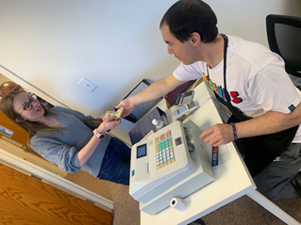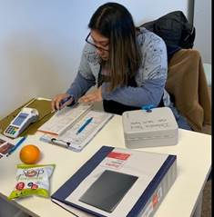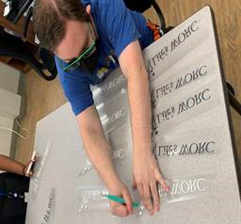

Queens locations |  | Long Island locations
Glendale  Queens Village |  | East Rockaway  Garden City  Old Bethpage  Islandia

For more information, please contact our Admissions Department
at (516) 741-9000 or admissions@lifesworc.org

Day Habilitation

