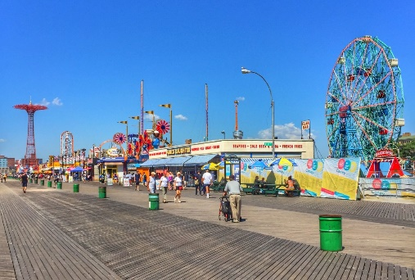
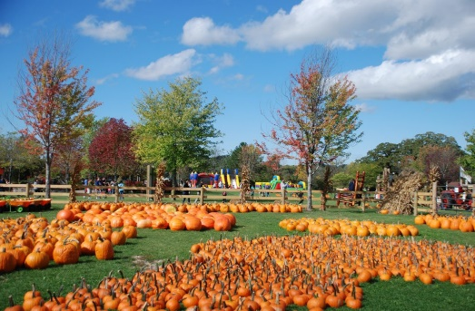
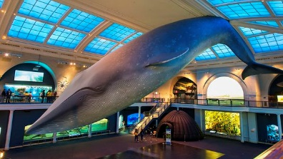
Respite/Recreation Program

Respite/Recreation provides a variety of activities for individuals ages 18+. Individuals who are interested in this program must be able to maintain basic safety with a small group (staffing ratio of 6:1) in the community and require minimal assistance with self-care.

PROGRAM HIGHLIGHTS
- Variety of community trips include local fairs/festivals, museums, zoos, amusement parks,
and more
- Small groups are supervised by well trained staff
- Convenient hours (10:00 am – 4:00 pm) every Saturday and Sunday

Queens
Transportation provided for trips. Trip schedule subject to change.

For more information, please contact our Admissions Department
at (516) 741-9000 or admissions@lifesworc.org

