Family Support Services

Service Access Provider

(Non-Medicaid)
Service Access Coordinator for individuals with intellectual and/or developmental disabilities who are not eligible for Medicaid. Services include linkage, referrals, crisis intervention and advocacy.
Long Island
Nassau CountySuffolk County
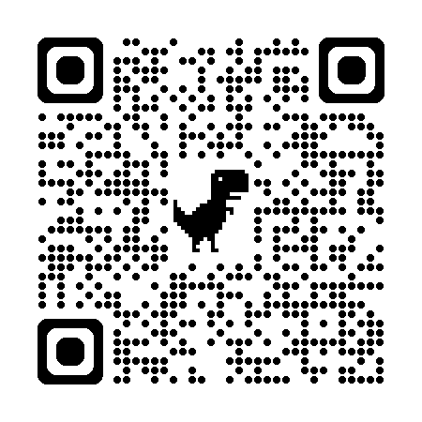

To Apply for Services please contact:
Natasha Salazar
110 Jericho Turnpike, Suite 103 Floral Park, NY 11001
Tel: (516) 292-3000 ext. 401
Fax: 516-292-4090
Email: nsalazar@cfsny.org
Website: www.cfsny.org

